Assets and Sources:
- Back_Light_Color, plane_tree_Trunk, and Cardvoard_boxes(…) are from the Unreal FAB market place. They were for free needed no extra crediting.
- The two water textures are from, the starter content
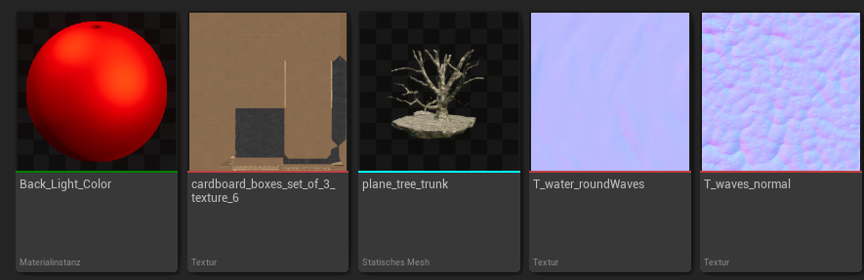
- The UI assets have been created by chatGTP
- The entire rest is from the previous DuoDash Team

